**Team 1**

**1. Create a Basic html page with using all below**

* Use all markup semantic tags
* Simple survey form
* Create table store some records (ex. Students, Employees).
* (Try to use all html tags).
* All should have different survey form.

For survey form reference

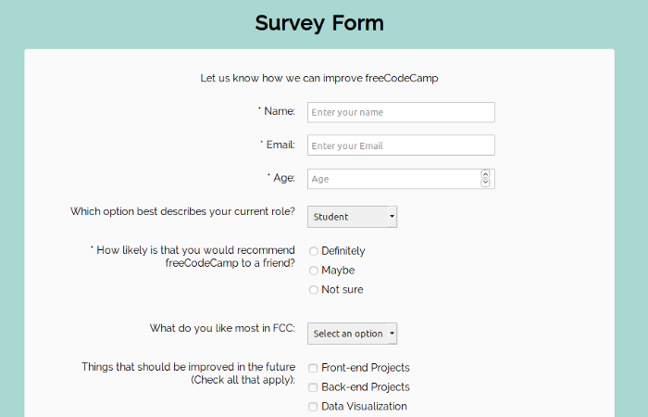

Save the file as a note pad and upload in the google drive link shared to you, the note pad should be your psnumber.html extension, (eg.10695059.html)

Team 2

1. **Create a Basic html page with using all below** 
   1. **LTI Training Schedule using Forms and table.**
   2. **Before the schedule give heading as organization name, academy name, current date, and time.**
   3. **At end give prepared by, approved by and submitted by, name and sign. For Sign you should upload an image.**
   4. **Give a new course link on same timetable to connect with Some Sample ToC of few Technologies.- when clicked new page should open.**

Save the file as a note pad and upload in the google drive link shared to you, the note pad should be your psnumber.html extension, (eg.10695059.html)

L&T Infotech

Digital Engg Academy Date and Time

|  |  |  |  |  |  |  |
| --- | --- | --- | --- | --- | --- | --- |
| Day/Time | 9.00 to 11 |  |  |  |  |  |
| Monday |  |  |  |  |  |  |
| Tus |  |  |  |  |  |  |
| Wed |  |  |  |  |  |  |

FSD Technologies

HTML

JS

CSS

HTML

|  |  |  |  |
| --- | --- | --- | --- |
| S.No | Topic | Subtopic | Hours |
| 1 | Intro HTML | What is HTML | 2 |
|  |  |  |  |

\

Prepared By Approved By

Team 3

HTML Practice Exercise

• Read chapters 1 - 4 in the SAMS’ book

• Create the html file at the top of page 15 in your book

o Create the file using a plain text editor such as Notepad

o Save it as Exercise1.htm

The default file type is .txt. If you do not save your file as .htm instead of .txt if will not display as a web page when you open the file,

o Open the file in your browser to verify it is correct

To open the file: double click the file or

Open your browser, hold the ctrl key and type O, click Browse to locate your saved file, highlight the file, Open the file, and click OK.

• As you read the chapters in the SAMS’ book try the examples by typing them into a plain text editor, save and view them to see what happens

Team 4

Prepare for the quiz and your first HTML assignment.

Answer the following questions as you read chapters 1 and 2.

1. What special character is used in an ending HTML tag?

2. What tags surround the part of an HTML file that appears to the user on the HTML page?

3. What are the two main parts of an html file? What tags create them?

4. What are the delimiters for HTML tags? (What characters surround most html tags?)

5. What extension do you use to save an HTML file?

Answer the following questions as you read chapters 3 and 4.

1. What tags are needed to create headings?

2. What tags are needed for the following?

a. Bold

b. Paragraph

c. Line break

3. Special characters start with_______ and end with ______.

4. What is the symbol for inserting a space?

5. What tag is needed to create a link? What attribute?

6. What tag is needed to create a link to an e-mail address? What attribute?

7. How can you distinguish a link to a URL from a link to an e-mail address?

The exercise and the questions are for practice to help prepare for the quiz and the first HTML assignment.